**INDUSTRIAL SUMMER TRAINING REPORT**

Submitted by:

**Lekhraj singh**

**Institute of Engineering and**

**Technology**



# Table of contents

Table of contents 1-2

Abstract 1-4

Acknowledgement 1-5

1. Introduction 1-6

1.1 Overview and Motivation 1-6

1.2 Objective 1-6

1.3 Summary of similar Applications 1-7

2. Company Profile 2-8

3. Project Design 3-9

3.1 UML Diagrams : 3-9

3.1.1 Use-case Diagram : 3-9

3.2 Database Design : 3-10

3.2.1 E-R Diagram : 3-10

3.2.2 Data flow diagram : 3-11

4. Implementations and User Interface 4-12

4.1 Implementation 4-12

4.2 Technologies Used 4-12

4.2.1 HTML 4-12

4.2.2 CSS 4-12

4.2.3 JavaScript 4-13

4.2.4 Node. JS with Koa framework 4-13

4.2.5 JQuery 4-13

4.2.6 Bootstrap 4-13

4.2.7 EJS (Embedded JavaScript) 4-14

Redis Server 4-14

4.3 User Interfaces 4-14

4.3.1 Homepage 4-14

4.3.2 Gallery 4-15

4.3.3 Events 4-16

4.3.4 Event Details 4-17

4.3.5 Certificate 4-18

4.3.6 Signup and Login 4-19

4.3.7 Profile 4-20

4.3.8 My Events 4-20

4.3.9 About and Contact Us 4-21

Declaration 4-22

Certificate 4-23

# Abstract

This industrial report presents the experience gained during my six weeks of industrial training undertaken at GLA university's Projector club. My training was in Web Design and Advanced Web Design. I acquired practical knowledge on how to design a website and how to add and manage records in a database. This report discusses the technical skills gained during the training period and justifying the relevance of the scheme in equipping students with needed technical competence to thrive in the real world and I also have developed a real life problem solving website.

# Acknowledgement

The completion of this training work could have been possible with continued & dedicated efforts & guidance of a large number of faculty & staff members of the institute. I acknowledge our gratitude to all of them. The acknowledgement, however, will be incomplete without specific mention as follows I wish to acknowledge my deep gratitude to **Mr Piyush Khandelwal**, a Professor at GLAU for his cooperation and guidance. I am also thankful to his Lab assistant that provided staunch support throughout this training and helped me to complete the training successfully Furthermore I would also like to acknowledge with much appreciation the crucial role of our HOD **Prof. Anand Singh Jalal** for this encouragement & providing all the facilities in the department Finally, I would like to say that I am indebted to my parents for everything that they have done for me. All of this would have been impossible without their constant support. And I also thanks to God for being kind to me and driving me through this journey.

# Introduction

## Overview and Motivation

As a computer science student in GLA University, I have faced a problem that is to know the details of past and future events happening at our university. So to solve a real-life problem I decided to work on this project. Now when everything is happing online my team and I decided to do this project under the guidance of **Mr Piyush Khandelwal** who was our mentor as well as a motivator throughout the completion of the project. In the process of developing this website, we have also learned a lot of new technologies.

## Objective

Being the student of the computer science and engineering the students and the coordinator should be an ability to interact through the internet so the main aim of the abacus website is to provide an online platform where the student and the coordinator easily interact with each other in a convenient way.

The main objective of the abacus website is to show the students (users) the information about the events that have happened previously and the events which will be happening in the future. The abacus website will also display the media of the events which have been conducted in the past and also one of the most important functionality of the abacus website to generate the online certificates so that students should not have any problem to get their certificate.

## Summary of similar Applications

There are millions of similar applications available in the market on a commercial level or some for personal uses or some for non- commercial level.

We can take the example of [**http://robothlon.com**](http://robothlon.com) which organizes the events in **IIT Delhi**. Here we (Event Coordinators or Admins) can organize the events. Users can download the media (Videos, Audios, Photos or others) of previous events. They can participation competitions and register in the events. They can also get the certificate of participation if they registered and attended the event.

All these websites are made on some similar technologies. Another similar example we can take of [**http://techfest.com**](http://techfest.com)

# Company Profile

The PROJECTOR is not a company; it is a software project development cell at the GLA University. This helps students to be updated with the new technologies in the IT world and also to work on the live project that is being developed at this cell. This cell is managed by **Mr Piyush Khandelwal** he is an Asst. Professor at GLA University.

Projector targets to provide a solid platform to the students for learning and development which is built with the following ingredients:

1. Training students with cutting-edge technology.

2. Software development for local schools, colleges and businesses.

3. Fetching of live projects from the IT Companies for development at GLA University.

4. Helping students to convert their innovative ideas into real implementation.

# Project Design

## UML Diagrams :

### 3.1.1 Use-case Diagram :

## Database Design :

### 3.2.1 E-R Diagram :

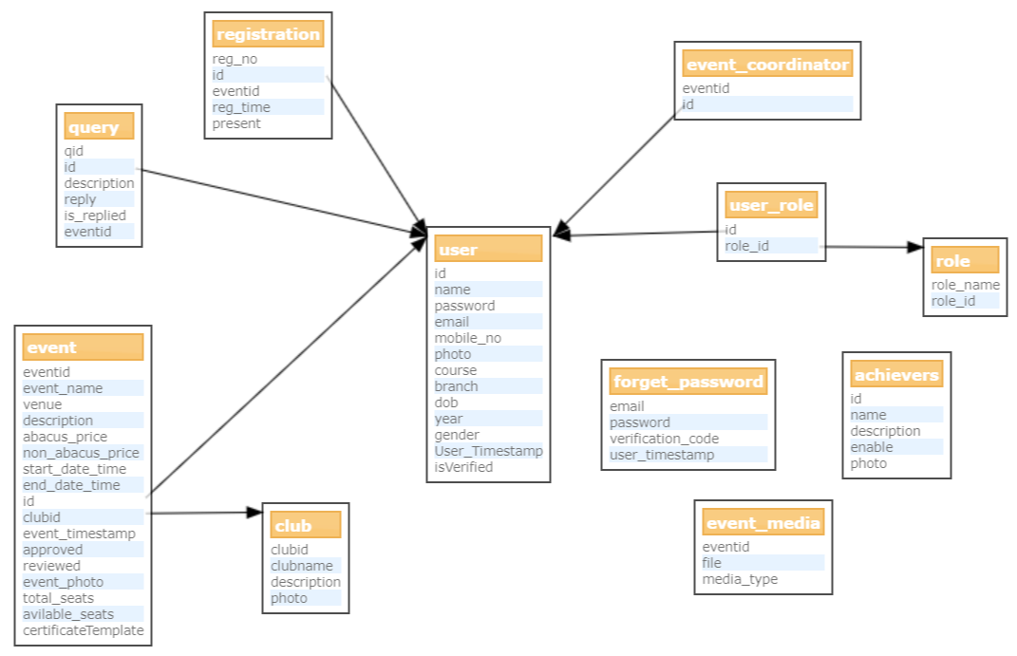

### 3.2.2 Data flow diagram :

**Event**

**Coordinator**

**User**

**Event**

**Media**

**Admin**

**Registration**

**Certificate**

**Login**

**User**

# Implementations and User Interface

## Implementation

Web development broadly refers to the tasks associated with developing websites for hosting via intranet or internet. The web development process includes web design, web content development, client-side/server-side scripting and network security configuration, among other tasks.

## Technologies Used

* HTML
* CSS
* JavaScript
* Node. JS with Koa framework
* JQuery
* Bootstrap
* EJS
* Redis server

### 4.2.1 HTML

HTML is the language used to create web pages. "Hypertext" refers to the hyperlinks that an **HTML** page may contain. "Markup language" refers to the way tags are used to **define** the page layout and elements within the page.

### 4.2.2 CSS

**CSS** stands for **Cascading Style Sheets**. **CSS** describes how HTML elements are to be displayed on the screen, paper, or in other media. **CSS** saves a lot of work. It can control the layout of multiple web pages all at once.

### 4.2.3 JavaScript

JavaScript is a programming language commonly used in web development. It was originally developed by Netscape as a means to add dynamic and interactive elements to websites. JavaScript is a client-side scripting language, which means the source code is processed by the client's web browser rather than on the web server. This means JavaScript functions can run after a web page has loaded without communicating with the server.

### 4.2.4 Node. JS with Koa framework

Node.js (Node) is an open source development platform for executing JavaScript code server-side. Node is useful for developing applications that require a persistent connection from the browser to the server and is often used for a real-time application such as chat, news feeds and web push notifications.

Node.js is intended to run on a dedicated HTTP server and to employ a single thread with one process at a time. Node.js applications are event based and run asynchronously. Code built on the Node platform does not follow the traditional model of receive, process, send, wait, receive. Instead, Node processes incoming requests in a constant event stack and sends small requests one after the other without waiting for responses.

### 4.2.5 JQuery

jQuery is a concise and fast JavaScript library that can be used to simplify event handling, HTML document traversing, Ajax interactions and animation for speedy website development. jQuery simplifies the HTML's client-side scripting, thus simplifying Web 2.0 applications development. jQuery is a free, open-source and dual-licensed library under the GNU General Public License. It is considered one of the favourite JavaScript (JS) libraries available today.

### 4.2.6 Bootstrap

**Bootstrap** is a free and open-source front-end **web framework** for designing **websites** and **web** applications. It contains HTML- and CSS-based design templates for typography, forms, buttons, navigation and other interface components, as well as optional JavaScript extensions.

### 4.2.7 EJS (Embedded JavaScript)

EJS is a simple templating language that lets you generate HTML markup with plain JavaScript. No religiousness about how to organize things. No reinvention of iteration and control-flow. It's just plain JavaScript.

### 4.2.8 Redis Server

Redis is an open source (BSD licensed), in-memory data structure store, used as a database, cache and message broker. It supports data structures such as strings, hashes, lists, sets, sorted sets with range queries, bitmaps, hyper logs and geospatial indexes with radius queries. Redis has built-in replication, Lua scripting, LRU eviction, transactions and different levels of on-disk persistence, and provides high availability via Redis Sentinel and automatic partitioning with Redis Cluster.

## User Interfaces

### 4.3.1 Homepage

At the home page of abacus website, the user can view the basic interface of the website on that one can view the main club list, team of abacus society, achievers of the events and the statistic of the details of the events happened in the university.

In the header section the user can view the gallery, events, certificates and can sign up and sign in and in the footer section one can see the contact details, about us page and the developer page links.

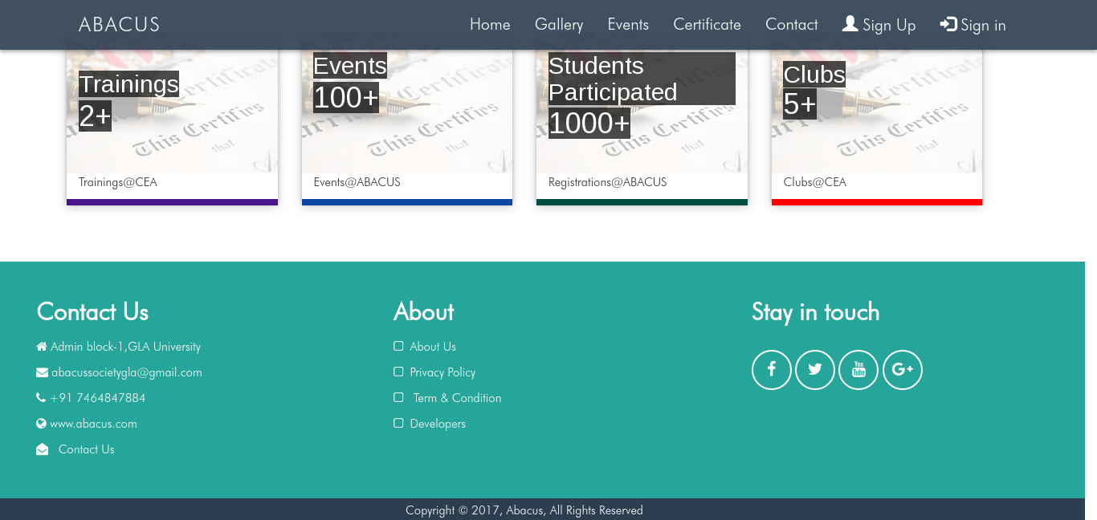.

### 4.3.2 Gallery

On the gallery page, the user can see the media of the events that had been happened in the past. The user can filter the media on the basis of the clubs, events and media. The user can see the media in the form of images and the Videos.

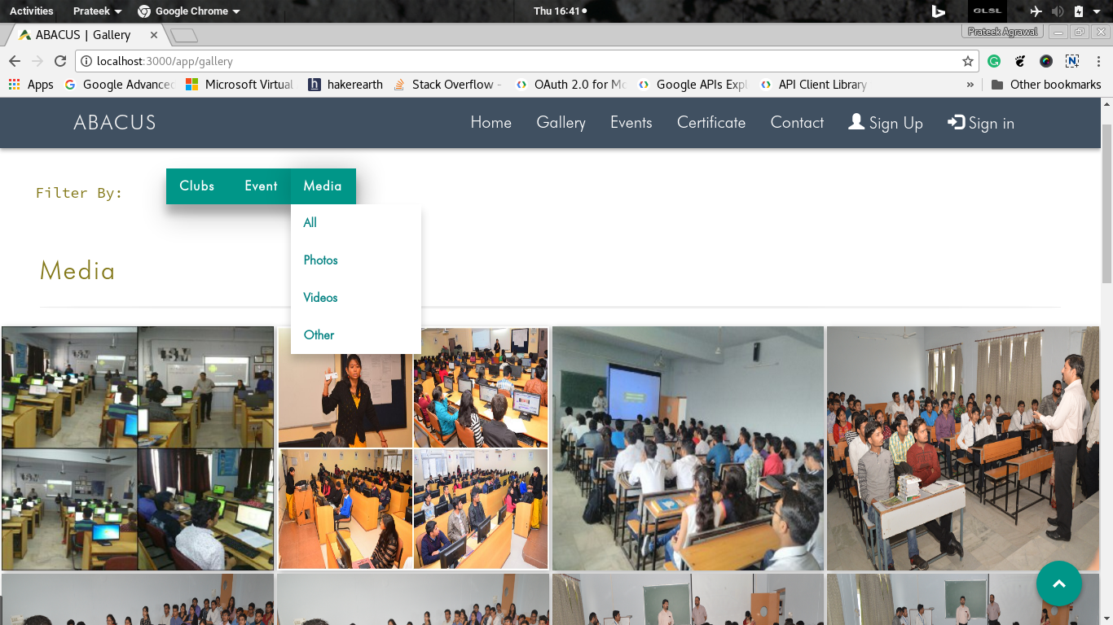

### 4.3.3 Events

on the event, page user can see the all the events and the user can also filter the events on the basis of the clubs and also on the basis of the status which has three values previous, upcoming and ongoing. On clicking the details button on the event user can view the all the details of the event and also can register and can generate the certificates.

On clicking on your events button user can also see the details of the events in which the user has been registered and can generate the certificates of the past events in which the user has registered and attended.

And on the same page, the coordinator can host the events that he wants to be hosted can see the status of the events that he has hosted and can also see the statics of the hosted events.

Also on the same page, the administrator can see all the information that a user and a coordinator can see and also the admin can approve the requested events and can delete and update the events on his convenience.

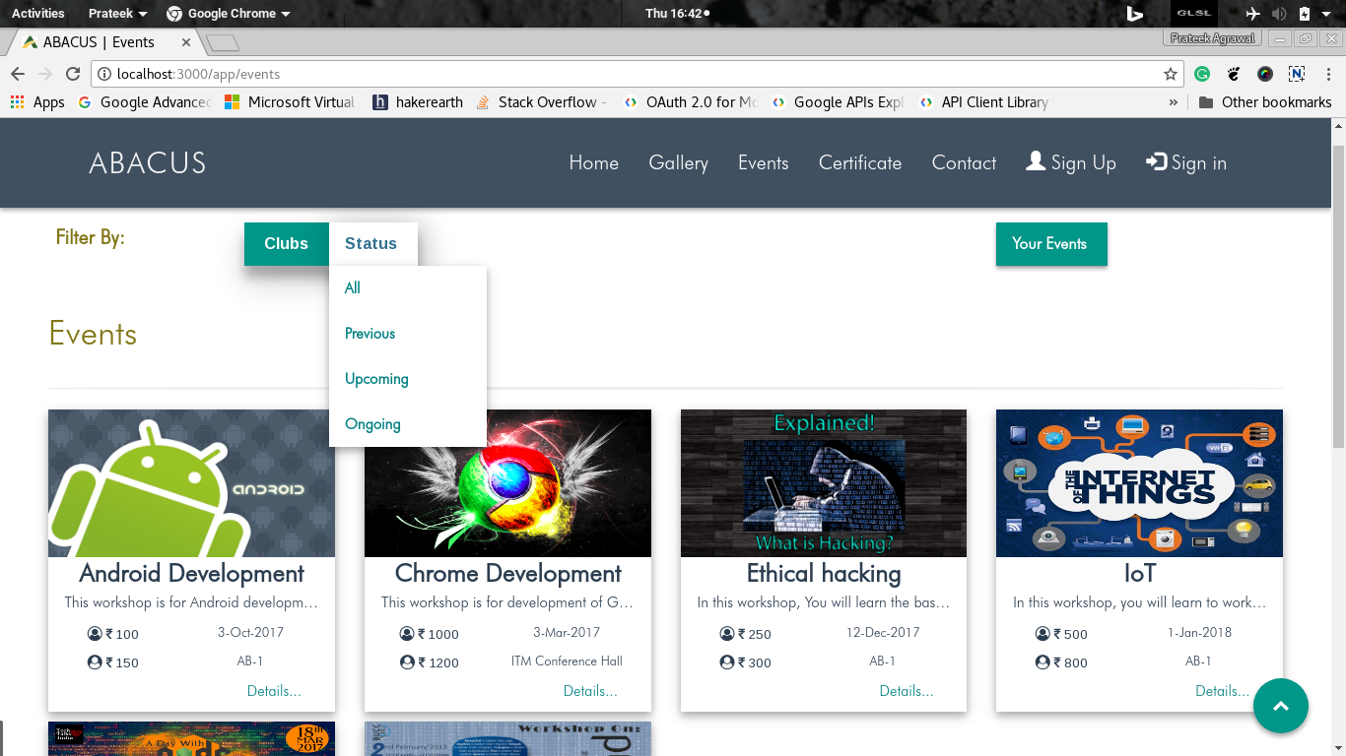

### 4.3.4 Event Details

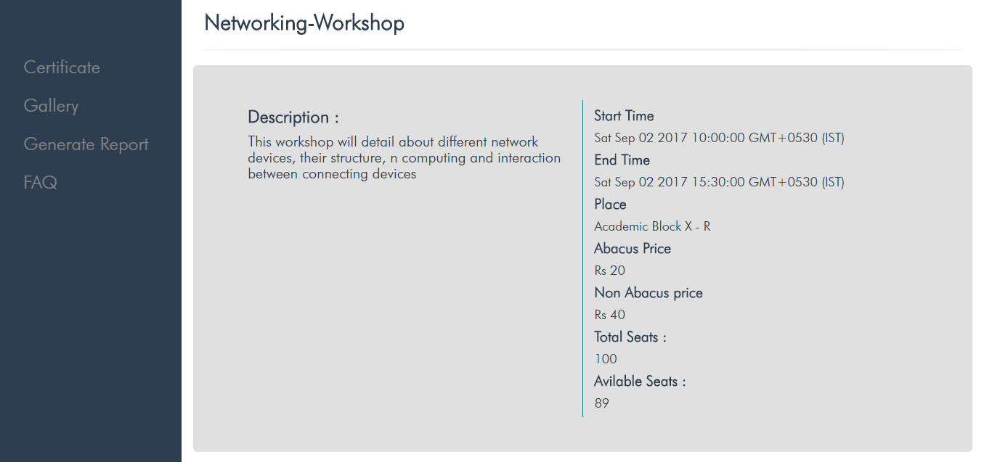By clicking On any Event, we can see the details of that event.

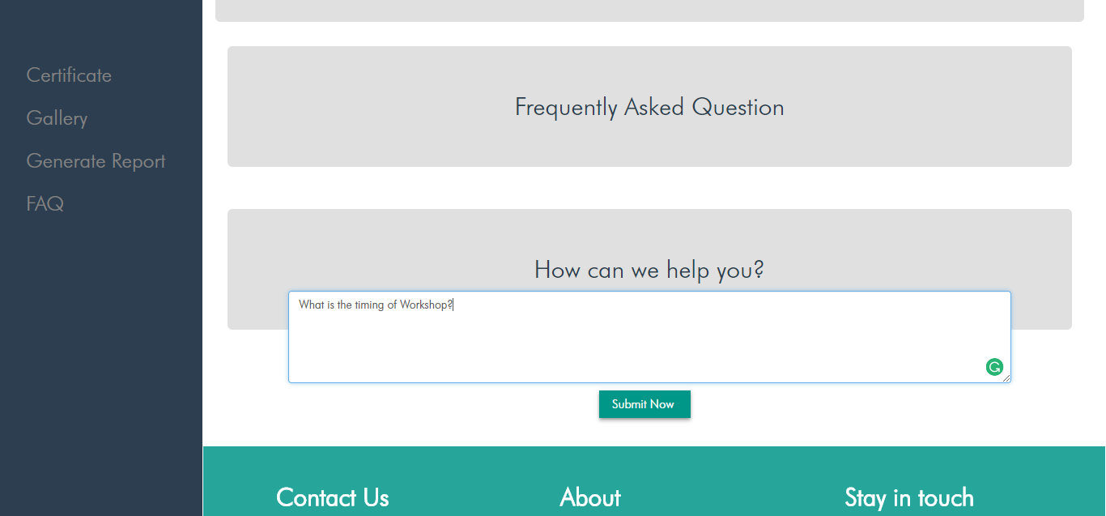

### 4.3.5 Certificate

### 4.3.6 Signup and Login

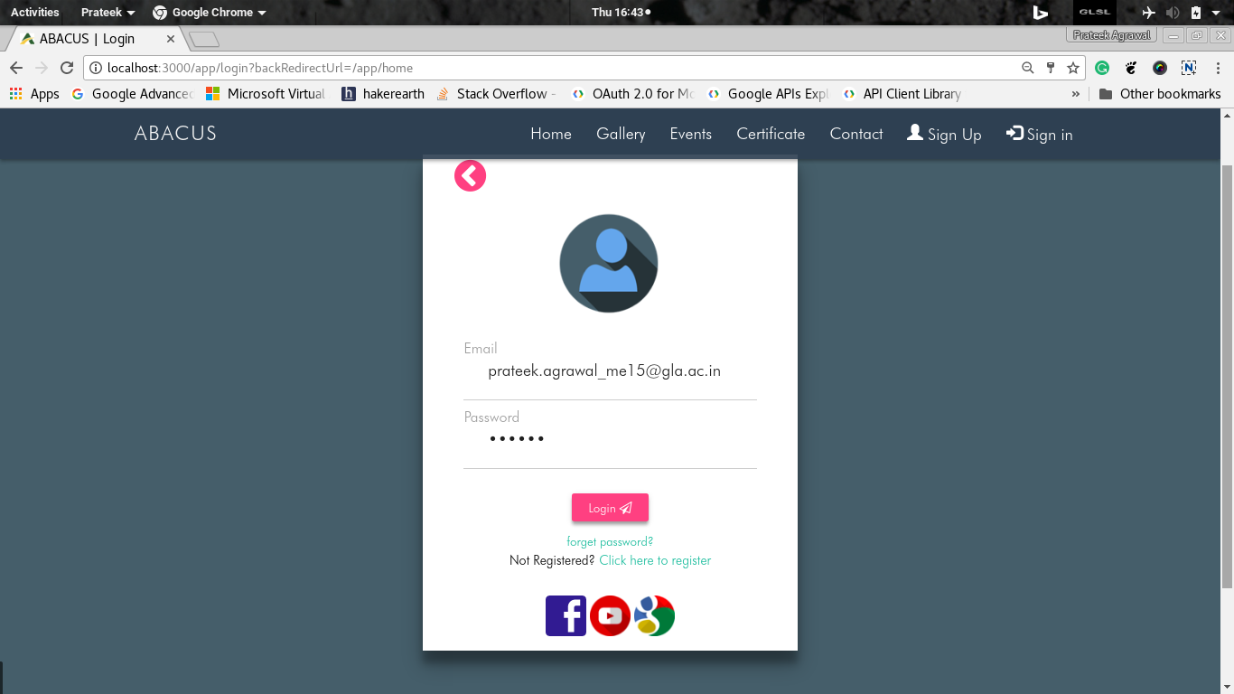

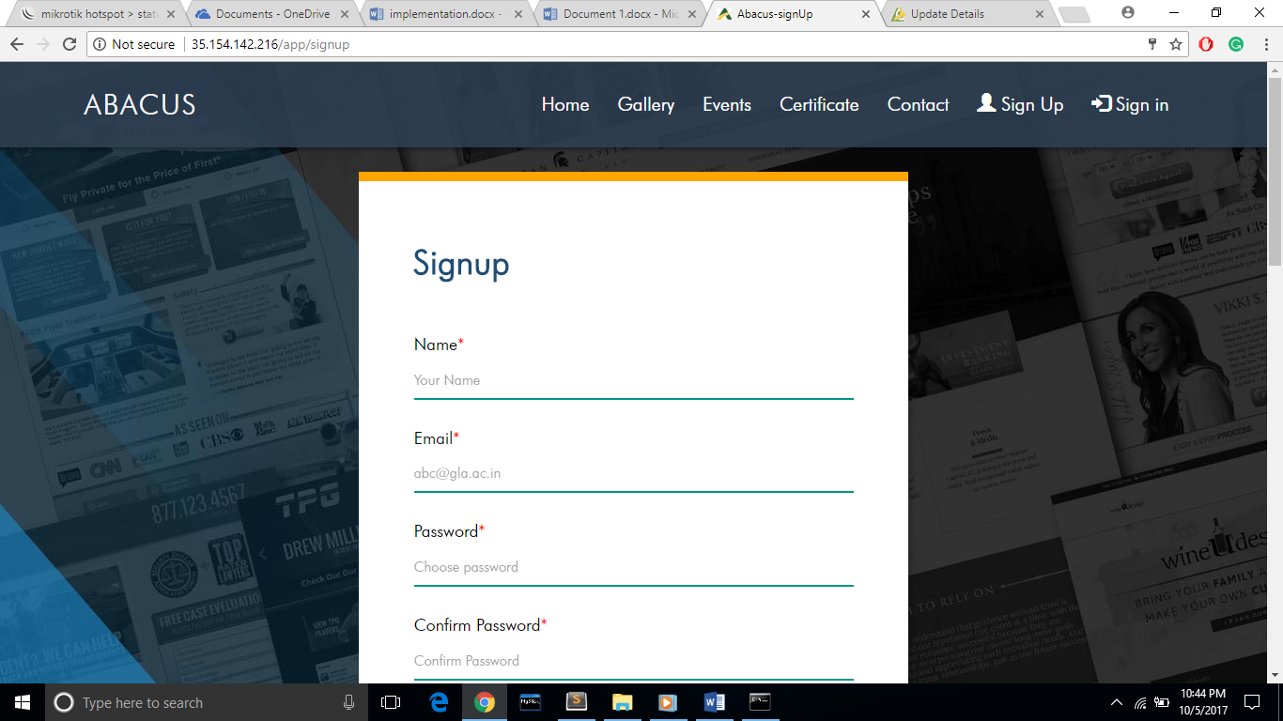

### 4.3.7 Profile



### 4.3.8 My Events

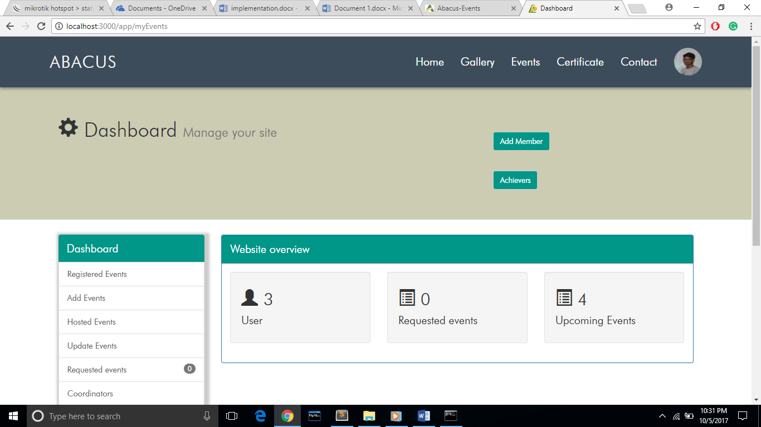

### 4.3.9 About and Contact Us

The user can contact the admin by using the contact us page by writing his message in the message box.

On About Us page user can see the details of the abacus society.

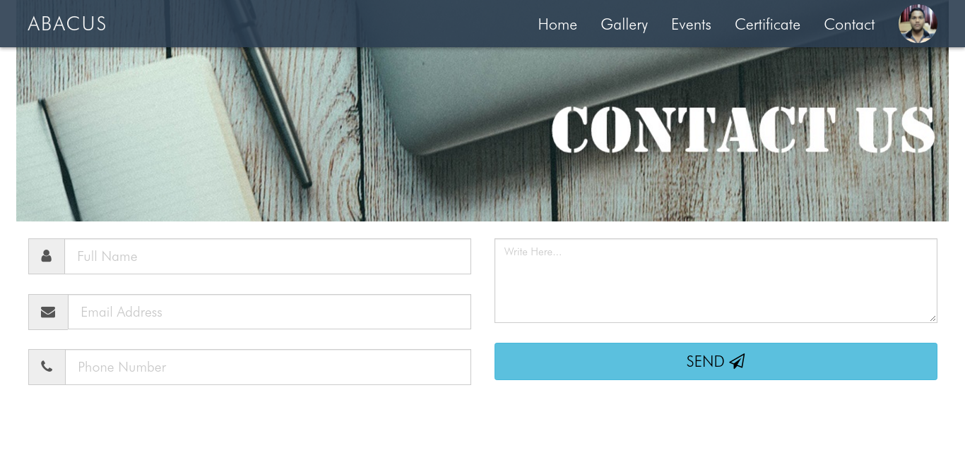

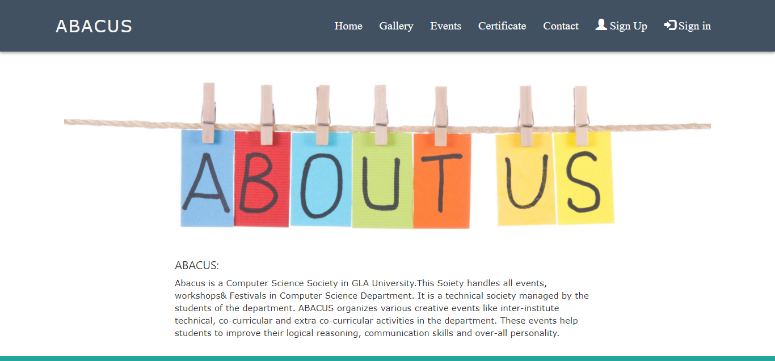

# Declaration

I hereby declare that the work which is being presented in the Training Project Report **“ABACUS WEBSITE”,** in partial fulfilment of the requirements for Industrial Project is an authentic record of my own work.

Sign ______________________

Name of Candidate: Lekhraj singh

University Roll No.: 151500275

# Certificate

This is to certify that the above statements made by the candidate are correct to the best of my/our knowledge and belief.

_____________________

**Project Supervisor**

Designation of Supervisor